nom __________________________________
Français 1 heure ______
Unité 2 : Le Moi Unique

CAN-DO STATEMENTS:

PRESENTATIONAL WRITING & SPEAKING
- I can spell aloud a name or place using the French alphabet
- I can present my identity to others
- I can describe myself in terms of appearance and personality

INTERPERSONAL SPEAKING
- I can greet others politely and appropriately
- I can ask and answer questions about who I am
- I can ask and answer questions about what I am like

INTERPRETIVE READING & LISTENING
- I can write the proper spelling of a name or place when I hear it spelled
- I can understand the general topic and some basic information from written texts about French-speaking young people
- I can understand the general topic and some basic information from spoken texts about French-speaking young people

classroom website: madamelinkowski.weebly.com

Leçon 1 : Tu viens d’où ?
Communicative Goals | - I can ask and answer questions about where others and myself are from.  - I can spell out my name to others.  - I can write out someone’s name when spelled to me.
Révisez!
Je m’appelle… | My name is…
Comment t’appelles-tu? | What is your name?
Tu t’appelles comment?
Comment ça s’écrit ? | How is that spelled?

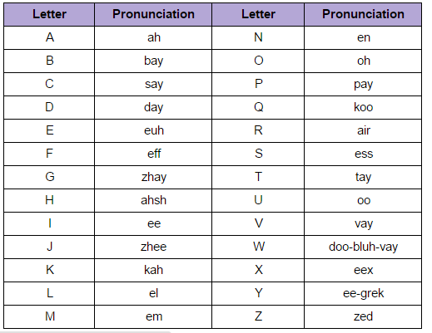 | Les numéros  0 zéro  1 un  2 deux  3 trois  4 quatre  5 cinq  6 six  7 sept  8 huit  9 neuf  10 dix

Nouveau vocabulaire
Quel est ton numéro de téléphone ? | What is your telephone number?
Mon numéro de téléphone est… | My phone number is…
Tu viens d’où ?  D’où viens-tu ? | Where are you from?
Tu es de [city] ? | Are you from [city]?
Je suis de [city]. | I am from [city].
Tu habites où ?  Où habites-tu ? | Where do you live ?
J’habite à [city]. | I live in [city]
Tu es [nationality] ? | Are you [nationality] ?
Je suis… | I am…
américain(e) | American
mexicain(e) | Mexican
français(e) | French
anglais(e) | English
canadien(ne) | Canadian
haïtien(ne) | Haitian
amérindien(ne) | Native American
africain(e) | African
bangladais(e)/bengali(e) | Bengladesh/Bengali
Tu es de quelle origine ? | What is your heritage ?
Je suis d’origine… | My heritage is…

Tips to make my language more sophisticated:
Je m’appelle … et j’habite à …
Je suis de … mais (but) j’habite à …
Je suis … et je suis d’origine…
Je suis … et je ne suis pas …
Je suis … parce que (because)…

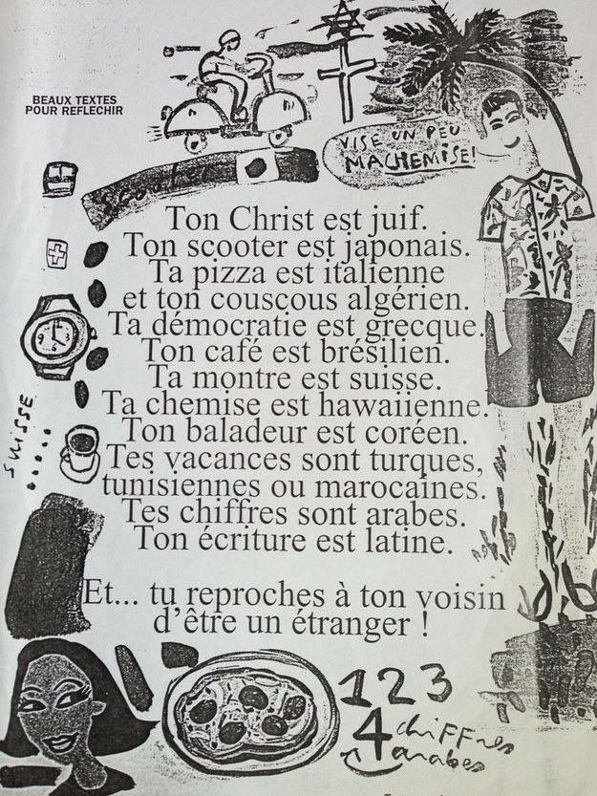
L’étranger
A. Key word recognition:
Find the French word/phrase that best expresses the meaning of each of the following English words/phrases. Please use only words from the text.
- Stranger/foreigner _________________________________
- You criticize __________________________________
- neighbor __________________________________
B. Important phrases:
First, circle the letter of the five (5) ideas mentioned in the document. Then, write the letter of that idea next to where it appears in the text.
- Your Christ is Jewish.
- Your scooter is Chinese.
- Your democracy is Greek.
- Your watch is Swiss.
- Your vacations are Hawaiian.
- Your numbers are Arabic.
- And you love your neighbor for being a foreigner!
- And you criticize your neighbor for being a foreigner!

C. Purpose
- Using only information from the document, summarize the main idea of the poem in English.

D. Cultural comparison
- Can you think of a situation where foreigners are criticized in the United States today?

Activité 1 Les Introductions
Have each person on the identity card introduce him/herself. Include name, nationality, and hometown. At the bottom, write your own introduction.
Je m’appelle __________________________
Je suis ______________________
Je suis de ____________________
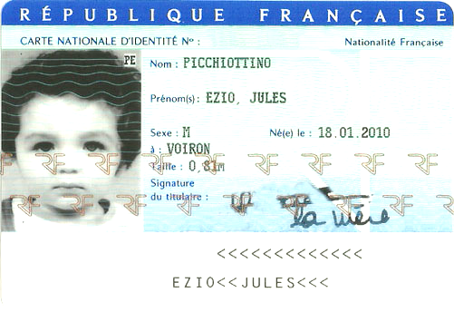
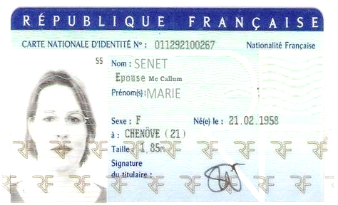
moi-même
- ____________________________________________________________________________
- ____________________________________________________________________________
- ____________________________________________________________________________

Conversation 1
With a partner, have a conversation that includes the following information.
- Introductions (including spelling out names)
- How people are doing
- Where you are from
- Where you live
- Your nationality
- Your phone number
Both you and your partner should be asking and answering the questions. Repeat the conversation until you can do it without the packet.

Leçon 2 : Les dates et les numéros
Communicative Goals | - I can ask and answer questions about the day of the week and the date  - I can ask and answer questions about my birthday.  - I can ask answer questions about my age  - I can count from 1 to 31.
Les numéros
1 | un | 11 | onze | 21 | vingt et un
2 | deux | 12 | douze | 22 | vingt-deux
3 | trois | 13 | treize | 23 | vingt-trois
4 | quatre | 14 | quatorze | 24 | vingt-quatre
5 | cinq | 15 | quinze | 25 | vingt-cinq
6 | six | 16 | seize | … | …
7 | sept | 17 | dix-sept | 30 | trente
8 | huit | 18 | dix-huit | 31 | trente et un
9 | neuf | 19 | dix-neuf | 32 | trente-deux
10 | dix | 20 | vingt | 33 | trente-trois
Vocabulaire
Jours de la semaine=Days of the week |  |  | Mois de l’année=Months of the year
lundi | /luhn-DEE/ | Monday | janvier | /zhan-VYAY/ | January
mardi | /mahr-DEE/ | Tuesday | février | /fay-VRYAY/ | February
mercredi | /mehr-kruh-DEE/ | Wednesday | mars | /mars/ | March
jeudi | /juh-DEE/ | Thursday | avril | /ah-VREEL/ | April
vendredi | /vahn-druh-DEE/ | Friday | mai | /may/ | May
samedi | /sahm-DEE/ | Saturday | juin | /zhwan/ | June
dimanche | /dee-MAHNSH/ | Sunday | juillet | /zhwee-YAY/ | July
 |  |  | aout | /oot/ | August
aujourd’hui | /oar-zhur-DWEE/ | today | septembre | /set-TAHMBR/ | September
demain | /deh-MAN/ | tomorrow | octobre | /ock-TOHBR/ | October
premier | /pre-MEEAY/ | first | novembre | /noh-VAHMBR/ | November
 |  |  | décembre | /day-SAHMBR/ | December
Quel jour sommes-nous ?  Quel jour est-ce ? |  |  | What day is it ?
Aujourd’hui, c’est [lundi]. |  |  | Today is [Monday].
Demain, c’est [mardi] |  |  | Tomorrow is [Tuesday].
Quelle est la date aujourd’hui ? |  |  | What is the date today?
Aujourd’hui, c’est le [huit aout]. |  |  | Today is [August 8th]
Quelle est la date de ton anniversaire ?  C’est quand, ton anniversaire ? |  |  | When is your birthday ?
Mon anniversaire est le [seize novembre]. |  |  | My birthday is [November 16th]
To form the date: |  |  | le + number + month
To say what day you will see someone: |  |  | À [samedi] ! (See you [Saturday])
Tu as quel âge ?  Quel âge as-tu ? |  |  | How old are you ?
J’ai [number] ans. |  |  | I am [number] years old

Tips to make my language more sophisticated:
J’ai … ans et mon anniversaire est le…
Aujourd’hui, c’est [day] [date].

Conversation 2
With a partner, have a conversation that includes the following information.
- Introductions (including spelling out names)
- How people are doing
- Where you are from and/or where you live
- Your nationality
- Your phone number
- Your birthday and age
Both you and your partner should be asking and answering the questions. Repeat the conversation until you can do it without the packet.

Conversation 3
With a partner, have a conversation that includes the following information.
- Introductions (including spelling out names)
- How people are doing
- What the day of the week it is
- What the date is
Both you and your partner should be asking and answering the questions. Repeat the conversation until you can do it without the packet.

Activité 2 Les numéros de téléphone
Find out the phone numbers of 3 students in class. Write out the numbers you hear.
Modèle : -Tu t’appelles comment ? |  |  | Je m’appelle Océan.
 | Comment ça s’écrit ? |  | O – C – E accent aigu – A – N
 | Quel est ton numéro de téléphone ? |  | 494-1805
Ask for their name: |  | Ask for their phone number:
Modèle: Océan |  | quatre neuf quatre - un huit zéro cinq

Activité 3 Les anniversaires et les âges
Find out the birthdays and ages of 3 people in class.
Modèle : -Tu t’appelles comment ? |  |  | Je m’appelle Océan.
 | Comment ça s’écrit ? |  | O – C – E accent aigu – A – N
 | C’est quand, ton anniversaire ?  Quelle est la date de ton anniversaire ? |  | C’est le 16 novembre.
 | Quel âge as-tu ?  Tu as quel âge ? |  | J’ai 17 ans
Ask for their name: |  | Ask for their birthday |  | Ask for their age
Modèle: Océan |  | le seize novembre |  | dix-sept ans

Leçon 3 : Comment es-tu ?
Communicative Goals | - I can describe my personality.  - I can identify someone after hearing/reading a description.  - I can ask and answer simple questions about my personality.
Vocabulaire
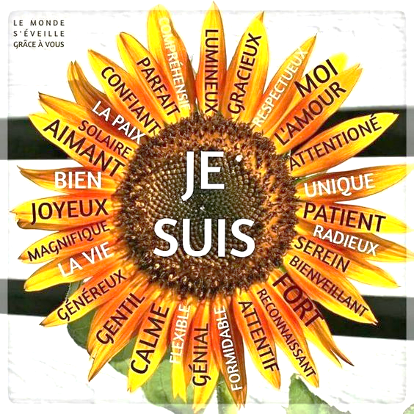
Comment es-tu ? | What are you like? / What is your personality?
Comment est ta personnalité ? | What are you like? / What is your personality?
Tu es [adjective] ? | Are you [adjective] ?
Je suis [adjective]. | I am [adjective].
timide | shy
sociable | social, out-going
sportif (sportive) | athletic
intelligent(e) | smart
drôle | funny
sympathique | nice
méchant(e) | mean
content(e) | happy
triste | sad
Comment est ton apparence physique ? | What do you look like?
Je suis [adjective] | I am…
beau/belle | handsome/beautiful
joli(e) | pretty
mignon(ne) | cute
jeune | young
vieux (vieille) | old
petit(e) | short
grand(e) | tall
Tu as les yeux [bleus] ? | Do you have [blue eyes]?
J’ai les yeux [bleus]. | I have [blue] eyes.
verts | green
gris | grey
marron | brown
noirs | black
noisette | hazel
Tu as les cheveux [longs] ? | Do you have [long] hair?
J’ai les cheveux longs | I have [long] hair
courts | short
mi-longs | mid-length
raides | straight
bouclés | curly
tressés | braided
crépus | natural
bruns | brown
blonds | blond
Je porte un hijab. | I wear a hijab (head scarf).
Tips to make my language more sophisticated:
Je suis … et je suis …
Je suis … et je ne suis pas …
Je suis … parce que (because)…
Je suis…et j’ai…
Écrivez 1
Write a description of yourself that includes the following information:

- Name
- where you live & where you are from (if different from where you live)
- nationality
- phone number
- age & birthday
- at least 2 personality traits
- at least 2 physical traits

Don’t forget to spell out your numbers!
Sentence Starters
Je suis |  | Use these sentence starters with adjectives  (ex: grand, américain, petit)  Practice Sentences:
Tu es
Il est
Elle est
Je ne suis pas
Tu n’es pas
Il n’est pas
Elle n’est pas

J’ai |  | Use these sentence starters with noun phrases  (ex : les yeux marron, les cheveux raids, 16 ans)  Practice Sentences :
Tu as
Il a
Elle a
Je n’ai pas
Tu n’as pas
Il n’a pas
Elle n’a pas

Conversation 4
With a partner, have a conversation that includes the following information.

- Introductions (including spelling out names)
- How people are doing
- What the day of the week and/or date is
- Where you are from and/or where you live
- Your nationality
- Your phone number
- Your birthday and age
- What you look like
- What your personality is

Both you and your partner should be asking and answering the questions. Repeat the conversation until you can do it without the packet.

