Reading ______ / 28 nom ___________________________________
Français 1-2
la date ___________________________________
Les fournitures scolaires
Look at the attached documents and answer the questions below. You must write in English unless otherwise stated.
Document 1 : Liste du matériel nécessaire à la rentrée 2015 pour les élèves de 3ème
Key Word Recognition (2 points)
- Highlight or circle 4 of your vocabulary words from page 12 found in the reading.
Guessing Meaning from Context (1 point)
- Based on the materials listed, what class do you think « EPS » is in America? _____________________________

Supporting Details (7 points)
Is the following information found in the reading? If so, place a check next to it and write IN ENGLISH the information that is given in the reading for each detail you have checked. If the detail is not in the reading, leave the lines blank.
- ______ The type of calculator you need for math class. ________________________________________________
- ______ The number of notebooks you need for history class. ________________________________________________
- ______ The writing utensil needed for English class. ________________________________________________
- ______ The types of pencils needed for art class. ________________________________________________
- ______ The type of notebook needed for French class. ________________________________________________

Document 2 : Matériel nécessaire à la rentrée 2012 pour les élèves de 6ème
Key Word Recognition (2 points)
- Highlight or circle at least 4 cognates.
Guessing Meaning from Context (2 points)
- Find the underlined phrases and write what you think they mean in English. (They are marked in the document with an arrow.) Do NOT use a dictionary/translator to help you!
  - 1 « souris » (le blanc correcteur liquide est interdit) _________________________________________
  - 1 règle de 15cm _________________________________________
Supporting Details (7 points)
- Name 4 items they need in their pencil case.
- _________________________________________  - _________________________________________ | - _________________________________________  - _________________________________________

- How many items are students supposed to bring with them on the first day of school? ________________
Name 2 of them _________________________________________ & _________________________________________

Documents 1 & 2
Main Idea (2 points)
- What is the purpose of these documents?
(Your response should tell me their purpose in real life, not how they are used in a language classroom.)

Comparing Cultural Perspectives (5 points)
- Name 3 similarities between what school supplies these French students need and those that you need.
- Name 2 differences.

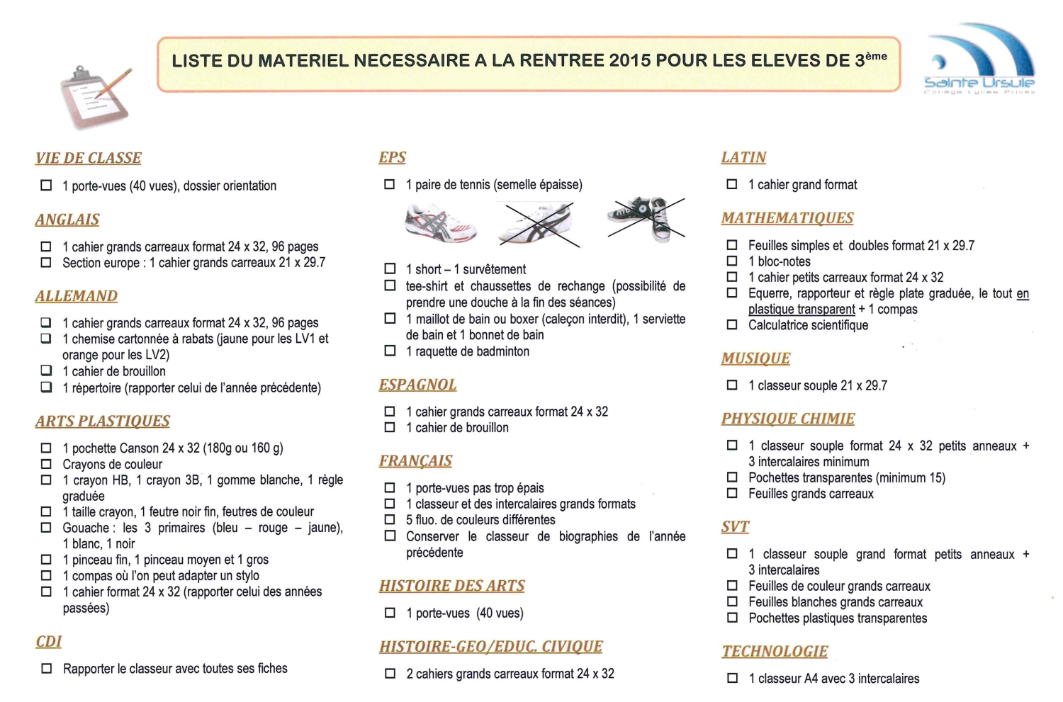
Document 1

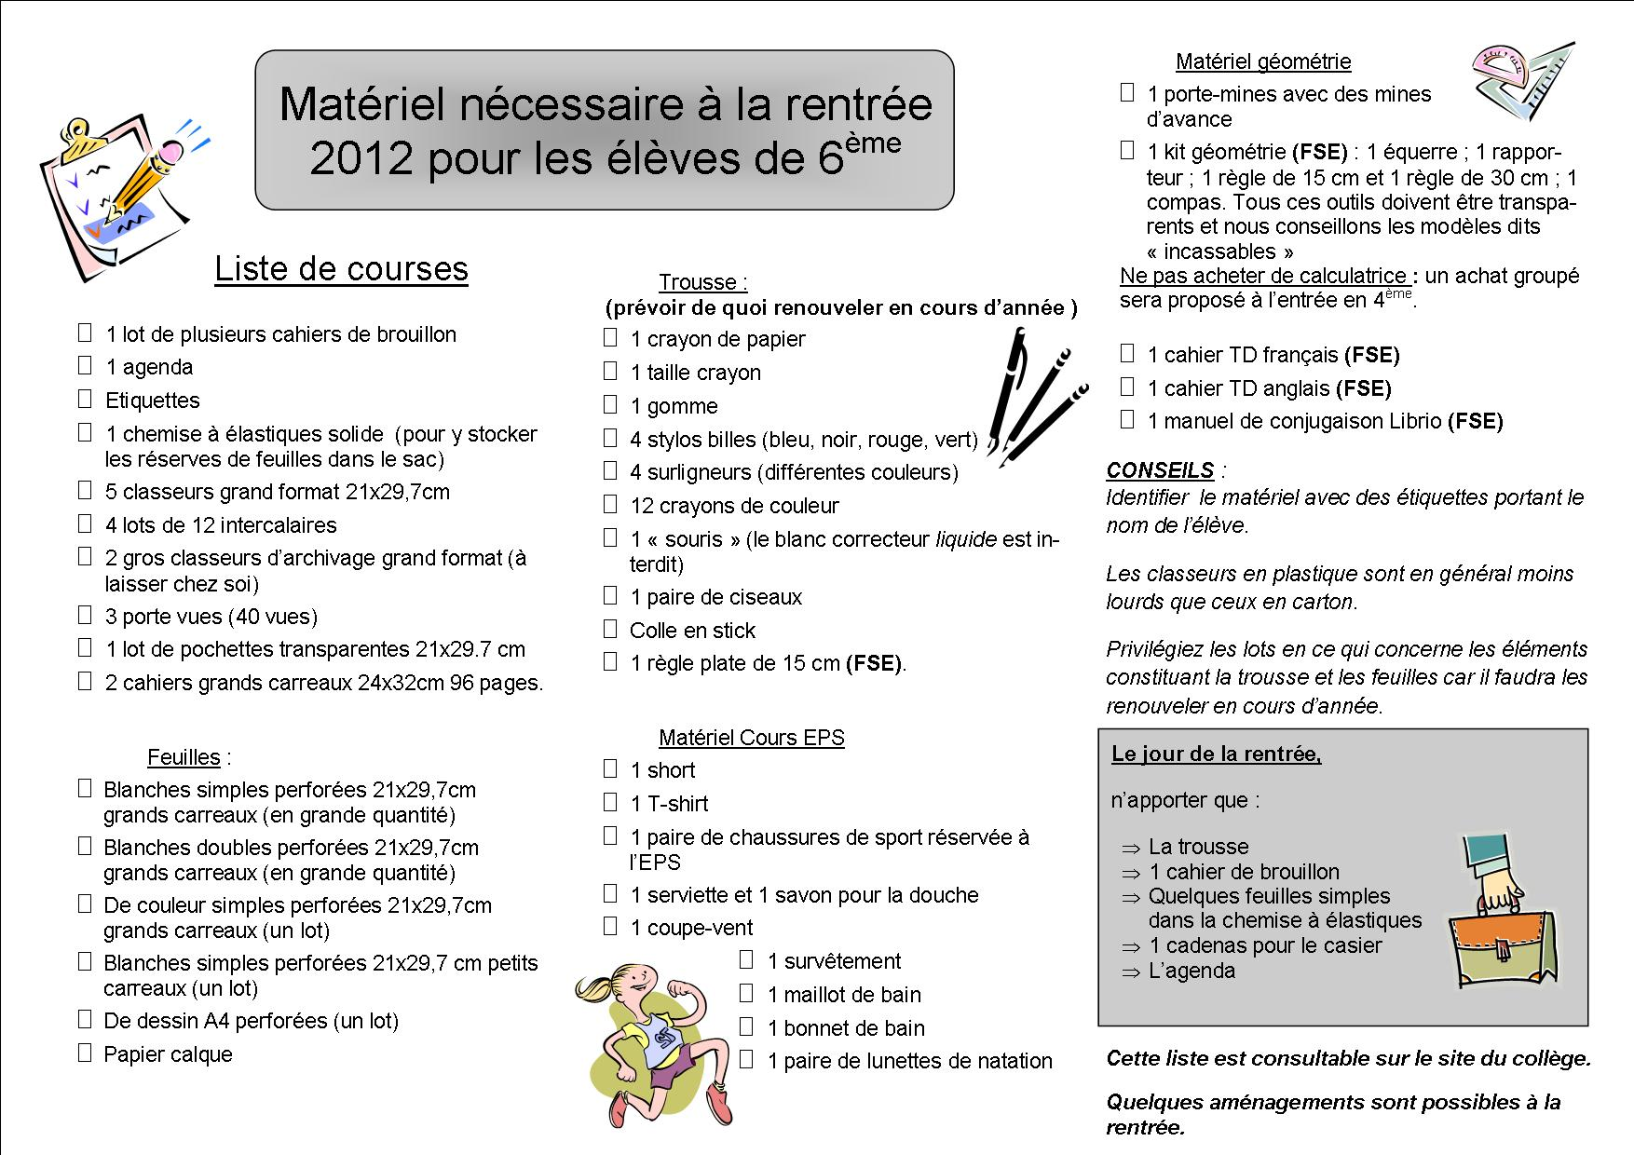
⬆
⬆
Document 2

