nom ___________________________________
Français 1
Unité 3 : Ce que j’aime et ce que je fais

Speaking
- I can ask and answer a variety of simple questions about what I like and don’t like to do
- I can ask and answer a variety of simple questions about what I do and don’t do.
- I can tell someone what I do after school and on the weekend

Presentational Writing
- I can express preferences about what I like and do not like to do.
- I can list what I do and don’t do in my free time.

Listening
- I can identify what people like and don’t like to do based on what I hear.

Reading
- I can identify what people like and don’t like based on what I read.
- I can use my knowledge of cognates to infer the meaning of words.

Classroom website: madamelinkowski.weebly.com

Leçon 1: Ce que j’aime faire et pas faire
Communicative Language Goals | - I can ask simple questions about what someone likes to do.  - I can answer simple questions about what I like and don’t like to do.  - I can write about what I like and do not like to do.  - I can count to 60.
Les numéros
0 | zéro |  | 10 | dix |  | 20 | vingt |  | 30 | trente
1 | un |  | 11 | onze |  | 21 | vingt et un |  | 40 | quarante
2 | deux |  | 12 | douze |  | 22 | vingt-deux |  | 50 | cinquante
3 | trois |  | 13 | treize |  | 23 | vingt-trois |  | 60 | soixante
4 | quatre |  | 14 | quatorze |  | 24 | vingt-quatre
5 | cinq |  | 15 | quinze |  | 25 | vingt-cinq
6 | six |  | 16 | seize |  | 26 | vingt-six
7 | sept |  | 17 | dix-sept |  | 27 | vingt-sept
8 | huit |  | 18 | dix-huit |  | 28 | vingt-huit
9 | neuf |  | 19 | dix-neuf |  | 29 | vingt=neuf

Est-ce que tu aimes… ? | Do you like…?
Qu’est-ce que tu aimes faire ? | What do you like to do?
j’aime…  j’aime bien…  j’aime aussi,,, | I like…  I really like…  I also like…
je n’aime pas…  je n’aime pas toujours… | I do not like…  I do not always like…
je préfère… | I prefer…
je veux… | I want…
je ne veux pas… | I do not want…
mais | but
et | and
ou | or

Les activités
chanter | to sing | jouer au basket | to play basketball
danser | to dance | jouer au foot | to play soccer
dessiner | to draw | jouer au football américain | to play football
déjeuner | to eat lunch | jouer au tennis | to play tennis
diner | to eat dinner | jouer aux jeux vidéo | to play video games
dormir | to sleep | lire | to read
écouter la musique | to listen to music | manger | to eat
envoyer des SMS | to text | nager | to swim
étudier | to study | parler (français, anglais, espagnol, bengali, ) | to talk/speak (French, English, Spanish, Bangla )
faire du jogging | to jog | regarder la télé  regarder un film | to watch TV  to watch a movie
faire de la photo | to take pictures | surfer l’Internet | to go online
faire des sports | to play sports | téléphoner | to talk on the phone / call
faire du vélo | to bike | travailler | to work
jouer | to play | voyager | to travel

Build more sophisticated language using the following phrases: | - J’aime … mais je préfère…  - J’aime … parce que (because)…  - Je n’aime pas … parce que…

Activité 1 Mes préférences
Indicate what you like to do in the following situations by completing the sentences below with an activity.
- En classe, j’aime…mais je préfère…
- En été (In the summer), j’aime…mais je préfère…
- Avec mes amis, j’aime…mais je préfère…
- Avec ma famille, j’aime…mais je préfère…
- Chez moi (At my house), j’aime…mais je préfère…

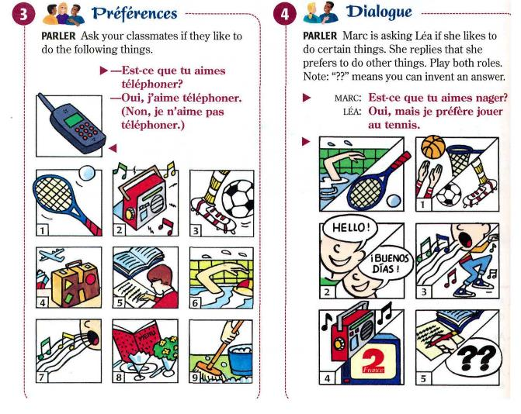
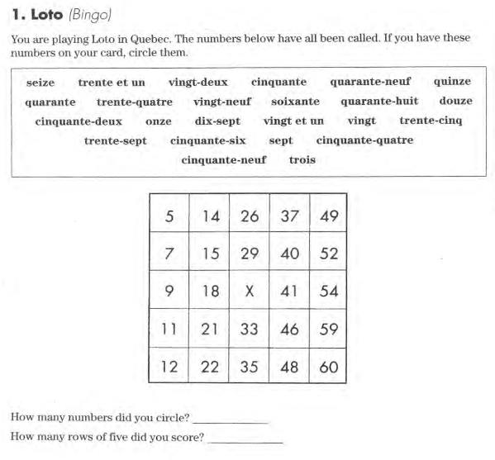
Conversation #1
You are meeting with your new language buddy and the two of you want to get to know each other better. Ask your new friend what he/she likes to do and doesn’t like to do. Be sure to answer your partner’s questions about what you like to do and don’t like to do so that the two of you can become better friends.
- Each of you should ask and answer at least 4 questions.
- Include both what you like to do and what you prefer to do.

Écrivez #1
You have been assigned an e-pal from Lebanon. You have received your first email and your e-pal wants to know what activities you like. On a separate sheet of paper, respond to your e-pals’s email by telling what you like to do and what you don’t like to do.
- Mention at least 5 activities you like/prefer to do and 3 activities you do not like to do.

Leçon 2 : Le temps & la géographie
Communicative Language Goal: | - I can read a weather report.  - I can describe the weather in different seasons where I live.  - I can recognize the names of countries on a map.  - I can identify major cities and geographical features of France.
Le vocabulaire
Quel temps fait-il ? |  | What is the weather ?
Il fait beau. |  | It is beautiful.
Il fait bon. |  | It is nice/good.
Il fait chaud. |  | It is hot.
Il fait frais. |  | It is cool.
Il fait froid. |  | It is cold.
Il fait mauvais. |  | It is bad/ugly.
Il fait du soleil. |  | It is sunny
Il fait du vent. |  | It is windy.
Il est orageux. |  | It is stormy.
Il est nuageux. |  | It is cloudy.
Il pleut. |  | It is raining.
Il neige. |  | It is snowing.
Les saisons
en été | in the summer |  | en hiver | in the winter
en automne | in the fall |  | au printemps | in the spring

Révisez
Jours de la semaine=Days of the week
lundi | /luhn-DEE/ | Monday | vendredi | /vahn-druh-DEE/ | Friday
mardi | /mahr-DEE/ | Tuesday | samedi | /sahm-DEE/ | Saturday
mercredi | /mehr-kruh-DEE/ | Wednesday | dimanche | /dee-MAHNSH/ | Sunday

Mois de l’année=Months of the year
janvier | /zhan-VYAY/ | January | juillet | /zhwee-YAY/ | July
février | /fay-VRYAY/ | February | aout | /oot/ | August
mars | /mars/ | March | septembre | /set-TAHMBR/ | September
avril | /ah-VREEL/ | April | octobre | /ock-TOHBR/ | October
mai | /may/ | May | novembre | /noh-VAHMBR/ | November
juin | /zhwan/ | June | décembre | /day-SAHMBR/ | December

To form the date: | le + number + month  ** un (1) can’t be used with the date—you must use premier (first) instead**
To say what day you will see someone: | À [samedi] ! (See you [Saturday])
Quel jour sommes-nous ?  Quel jour est-ce ? | What day is it ?
Aujourd’hui, c’est [lundi]. | Today is [Monday].
Demain, c’est [mardi] | Tomorrow is [Tuesday].
Quelle est la date aujourd’hui ? | What is the date today?
Aujourd’hui, c’est le [huit aout]. | Today is [August 8th]

Activité 1 À Detroit
Say what the weather is like in Detroit in the following months. Use a different weather expression for each month.
Modèle: en juillet
En juillet, il fait chaud.

- en août
- en septembre
- en novembre
- en janvier
- en mars
- en mai

Activité 2 La date, la saison, & le temps
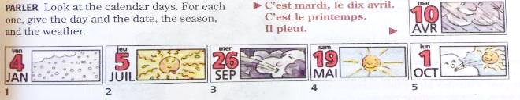

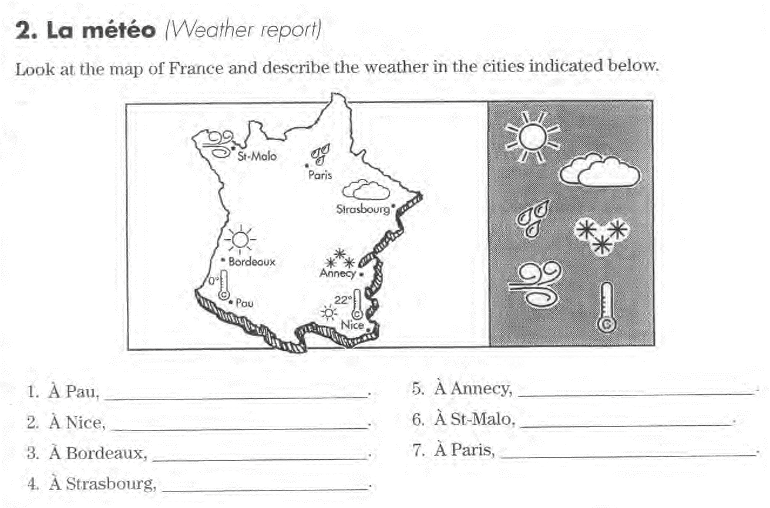

Conversation #2
Imagine that you are talking on the phone with an International student who will be visiting you soon. You each want to find out some information about each other:
- greet each other
- find out each other’s names
- ask what the weather is like in each season where you are
- Say goodbye

Écrivez! #2A
On a separate sheet of paper:
- write what you like to do and/or don’t like to do in each season
- choose 4 different weather expressions and say what you like, don’t like, or prefer to do

Les Endroits Places
à [city] / à Paris | in Paris |  | en classe | in class
en France | in France |  | en vacances | on vacation
aux États-Unis | in the United States |  | en ville | downtown
au restaurant | at the restaurant |  | à l’école | at school
au cinema | at the movies |  | chez moi | at my house
au travail | at work |  | chez [name] | at [name]’s house
au terrain de basket/foot/etc. |  | at the basketball court, soccer field, etc.
Qu’est-ce que tu aimes faire [location] ? |  | What do you like to do in [location]?
Qu’est-ce que tu aimes faire quand [weather expression] ? |  | What do you like to do when [weather expression]?
Qu’est-ce que tu aimes faire [season] ? |  | What do you like to do in [season]?
Qu’est-ce que tu aimes faire [location] quand [weather expression] ? |  | What do you like to do in [location] when [weather expression]?
Qu’est-ce que tu aimes faire [location] season] ? |  | What do you like to do in [location] in [season]?

Examples:
- _________________________________________________________________________________
- _________________________________________________________________________________
- _________________________________________________________________________________

Écrivez! #2A
On a separate sheet of paper:
- write 4 questions using the question starters in the box. Your questions should include a location, weather expression, season, or a combination of the 3.
- write answers to the 4 questions that you write

Leçon 3: Qu’est-ce que tu fais ?
Communicative Language Goal: | - I can talk about what I do on the weekends and after school.  - I can ask and answer simple questions about what I do.  - I can write a short description about what I do during my free time.
Vocabulaire
Qu’est-ce que tu fais ? |  | What do you do ?
The following phrases can begin or end a sentence or a question.
avant l’école |  | before school
après l’école |  | after school
le weekend |  | on the weekend
à [number] heures / à six heures |  | at [number] o’clock / at 6 o’clock
avec [person] |  | with [person]
mon ami | my friend | mon amie | my friend
mon père | my dad | ma mère | my mom
mon frère | my brother | ma soeur | my sister
mes amis | my friends | ma famille | my family
mes parents | my parents

Focus on form
Look at the difference between the underlined activities in the sentences below:
- J’aime danser. I like to dance.
- Tu danses le weekend? Do you dance on the weekend?
- Oui, je danse avec mes amis le weekend. Yes, I dance with my friends.
Why did the underlined activity change spelling?

How did the spelling change?
- no subject _____  - je _____  - tu _____ |  | This works for most verbs that end in -er

Look at how the verb faire changes in the sentences below:
- J’aime faire de la photo. I like to take pictures.
- Tu fais de la photo en classe ? Do you take pictures in class?
- Non, je fais de la photo en ville. Non, I take pictures downtown.
How did the spelling change?
- no subject _______  - je _______  - tu _______ |  | This works for any expression that uses faire.

Look at how the verb dormir changes in the sentences below:
- J’aime dormir. I like to sleep.
- Tu dors après l’école ? Do you sleep after school?
- Oui, je dors chez moi après l’école. Yes, I sleep at home after school.
How did the spelling change?
- no subject _______
- je _______
- tu _______

Look at how the verb lire changes in the sentences below:
- J’aime lire. I like to read.
- Tu lis après l’école ? Do you read after school?
- Oui, je lis avec mon frère après l’école. Yes, I read with my brother after school.
How did the spelling change?
- no subject _______
- je _______
- tu _______

To make a sentence negative:
Look at the difference between the underlined activities in the sentences below:
- Lundi, j’étudie. Le weekend, je n’étudie pas.
- Je parle français. Je ne parle pas anglais.
- Je joue au basket. Je ne joue pas au tennis.
 | How do you make a sentence negative in French? |  | What happens to ne before a vowel?
Pratiquez la conjugaison
Complete each of the sentences below with the correct form/conjugation of the verb of the verb in parentheses. Faites attention! sometimes the verb will need to change and sometimes it won’t!
- J’aime ________________________ (faire) des sports, mais je préfère _______________________ (jouer) au basket.
- Tu ________________________ (nager) en été ?
- Tu ________________________ (étudier) après l’école?
- Je ________________________ (surfer) l’Internet tout le temps (all the time).
- Je ________________________ (faire) de la photo en vacances.

Conversation #3
You are meeting with your language buddy again. This time you will discuss what you do during your free time. Ask each other at least 5 questions:
- what he or she does after school and on the weekends
- where and with whom he/she does these activities

Écrivez #3
On a separate sheet of paper, say what you do/don’t do in the following situations. You must use a different activity in each sentence.
Modèle: on the weekend
Le weekend, je travaille. -OR- Le weekend, je n’étudie pas.
- in the summer
- after school
- before school
- in the winter
- at the movies
- at my house
- with my friends

